* **Name**: Yonghun Jeong
* **ID** : 111802100
* **E-mail** : [yonghun.jeong@stonybrook.edu](mailto:yonghun.jeong@stonybrook.edu)
* **Unity version** : 2018.4.17f1 (LTS)
* **Hardware used :** Occulus Request(headset), Two Touch Controller(handler), ipod(for recording), iphone SE(Headset Casting for rendering headset)
* **Directory hierarchy**

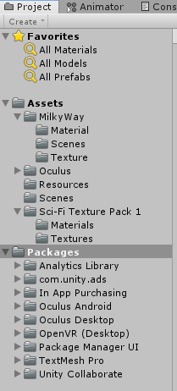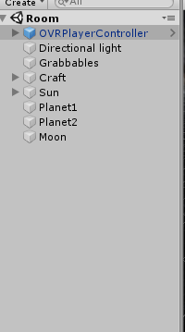

* **Any extra functionalities /features that you implemented for this assignment**

1. I used free asset for skybox and texture from “Milky way skybox” and “Sci-Fi Texture Pack 1”.
2. Implemented and designed space craft and planets. Also, I gave some light effect inside of the craft to be shown fancy and nice.
3. I used OVRPlayerController to use handler and headset. You can check it in the video.

* **Details on implementation: programming language used; references to the downloaded 3D models or how did you design your own model; how did you design the spaceship; how the lights and shadows in your scene were implemented, to mention but a few**

I used “occulus Integration” to set up the VR . This is basic format that I was able to manipulate my view by controller and headset. I do not make code for implement homework 0. Almost everything tat I have done in this homework is design space craft and milky way skybox and other planet. In case of Sun, I added spot light to give light effect. So In front of the window of the craft, there is a small amount of light coming from the Sun. other planets size are similar and made by sphere. To differentiate the each planet, I added texture. By changing Albedo, Metalic and Smoothness, It looks like a real planet when I see it in VR. To design a craft, I used cubes. Adding attaching the cubes, I made the craft, when it comes to design, I think about the artificial satellite. The most importance thing that I consider is texture. Since it gives lots of effect and reality, I used free texture asset(Sci-Fi Texture Pack 1). Also, I gave lots of attention to the cockpit. I made a stair and table for controlling the craft. By moving left and right, it would be able to manipulate craft in lots of ways. Also, To give fancy effect, I added pink light in the middle of the table. It would be activate and deactivate by the pilot’s existence

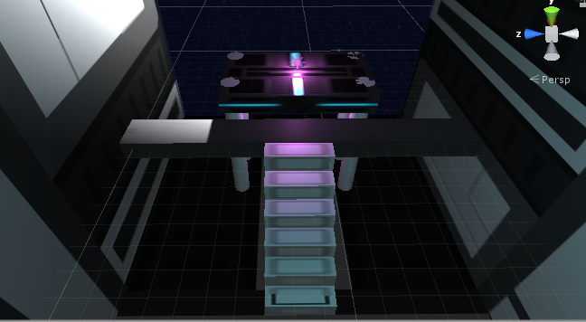

Reference

1. Milky way skybox (<https://assetstore.unity.com/packages/2d/textures-materials/milky-way-skybox-94001>)
2. Sci-Fi Texture Pack 1(<https://assetstore.unity.com/packages/2d/textures-materials/sci-fi-texture-pack-1-23301>)
3. Occulus Integration (<https://assetstore.unity.com/packages/tools/integration/oculus-integration-82022>)